**Documentation**

**Name-**

**Reg no-**

**Branch-**Information Technology

**Aim:**

Our website, HealthyHabit, aims to provide a comprehensive platform for individuals seeking to improve their physical and mental well-being through workout , healthy lifestyle practices, and insightful blogs. By offering a curated collection of workout videos, informative blogs, and resources for individuals at every level of their wellness journey, HealthyHabit endeavors to empower users to cultivate healthier habits and achieve holistic health and wellness. Additionally, our FAQ section addresses common questions and concerns, providing users with helpful answers and guidance. With BMI, BMR, and calorie calculators, HealthyHabit aims to empower users to assess their current health status, estimate their calorie needs, and set achievable fitness goals.

**Theory:**

* **Introduction to Holistic Health and Fitness**

At HealthyHabit, we believe in the power of holistic health and fitness, which encompasses not only physical well-being but also mental and emotional wellness. Our platform is designed to support individuals in cultivating a balanced lifestyle that prioritizes overall health and vitality.

* **Benefits of Workouts**

Regular exercise is essential for maintaining good health and fitness. Workouts not only improve physical strength, endurance, and flexibility but also enhance mental clarity, mood, and overall quality of life. Our diverse range of workout options caters to different fitness levels and preferences, ensuring that everyone can find a routine that suits their needs.

* **Blogs Section: Insights and Information**

In our blogs section, users can explore a wealth of informative articles, tips, and insights on various health and fitness topics. From nutrition advice to workout tips and mental wellness strategies, our blog content is curated to provide valuable information and guidance for individuals on their wellness journey.

* **FAQ Section: Addressing Common Questions**

Our FAQ section addresses common questions and concerns that users may have about health, fitness, and our platform. Whether it's about using our calculators, understanding workout techniques, or navigating the website, our FAQ section provides helpful answers and guidance to users.

* **Personalized Fitness Tools and Calculators**

We understand that each individual has unique health and fitness goals. That's why we've introduced BMI (Body Mass Index), BMR (Basal Metabolic Rate), and calorie calculators to help users assess their current health status, estimate their calorie needs, and set realistic fitness goals. These tools empower users to take charge of their fitness journey and make informed decisions about their health.

* **Empowerment Through Knowledge**

At HealthyHabit, we believe that knowledge is power. By providing users with access to educational resources, practical tools, and expert insights, we aim to empower individuals to make informed choices about their health and wellness. We believe that informed decision-making is key to achieving long-term success in fitness and overall well-being.

* **Implementation and Technologies used:**

**1. Website Development**

Our healthy habit website was developed using modern web development technologies mainly **HTML and CSS** and **JAVASCRIPT** in calculators. The website was designed to be user-friendly, visually appealing, and accessible across various devices.

**2. Frontend Technologies**

The frontend of the website was built using HTML5, CSS3, and JavaScript. These technologies were used to create the layout, style the content, and add interactivity to enhance the user experience.

**3. Styling Framework**

We utilized Bootstrap, a popular CSS framework, to streamline the development process and ensure consistency in design elements. Bootstrap provided a responsive grid system, pre-styled components, and customizable themes, allowing us to create a visually cohesive website efficiently.

**4. Version Control**

Git was used for version control, enabling collaboration among team members, tracking changes to the codebase, and facilitating the deployment process.

By leveraging these technologies and implementing industry best practices, we were able to create a robust and feature-rich health and fitness blog website that provides a seamless experience for our users.

* **Accessibility and Inclusivity**

We are committed to making health and fitness accessible to all. Our platform is designed to be user-friendly and inclusive, catering to individuals of all ages, backgrounds, and fitness levels. Whether you're a beginner just starting your fitness journey or an experienced athlete looking for new challenges, HealthyHabit welcomes you with open arms.

* **Continuous Improvement**

At HealthyHabit, we are dedicated to continuously improving and evolving our platform to better serve the needs of our users. We are committed to staying up-to-date with the latest advancements in health and fitness research and incorporating user feedback to enhance the user experience. Our goal is to create a dynamic and supportive community where individuals can thrive and achieve their health and fitness goals.

**CODE:**

[**https://github.com/HealthnFitness-Web/health_hub_fitness_tracker.git**](https://github.com/HealthnFitness-Web/health_hub_fitness_tracker.git)

**Screenshots:**

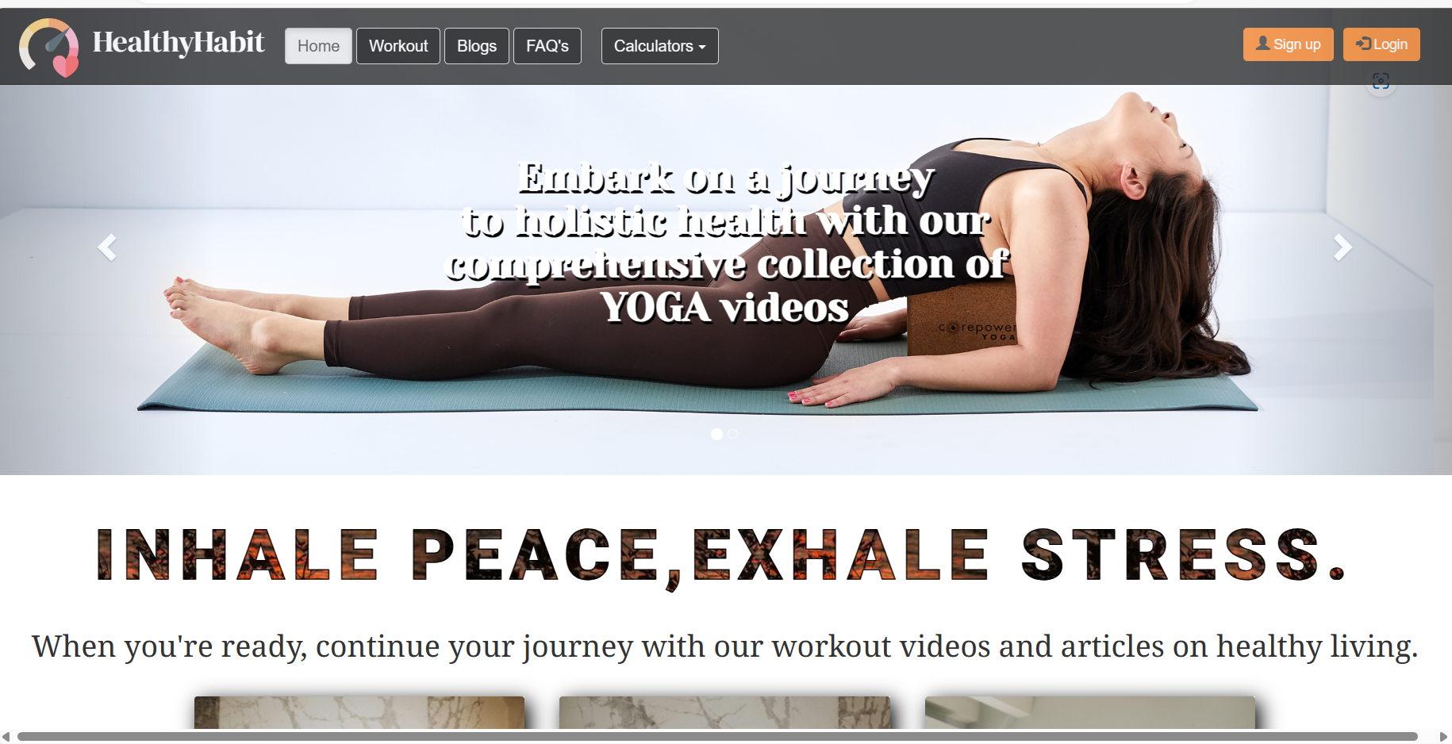

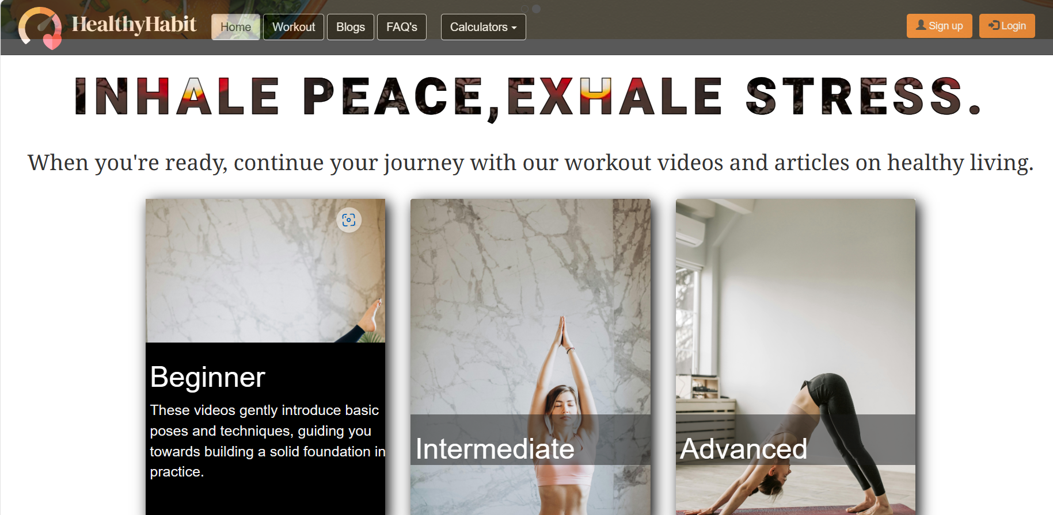

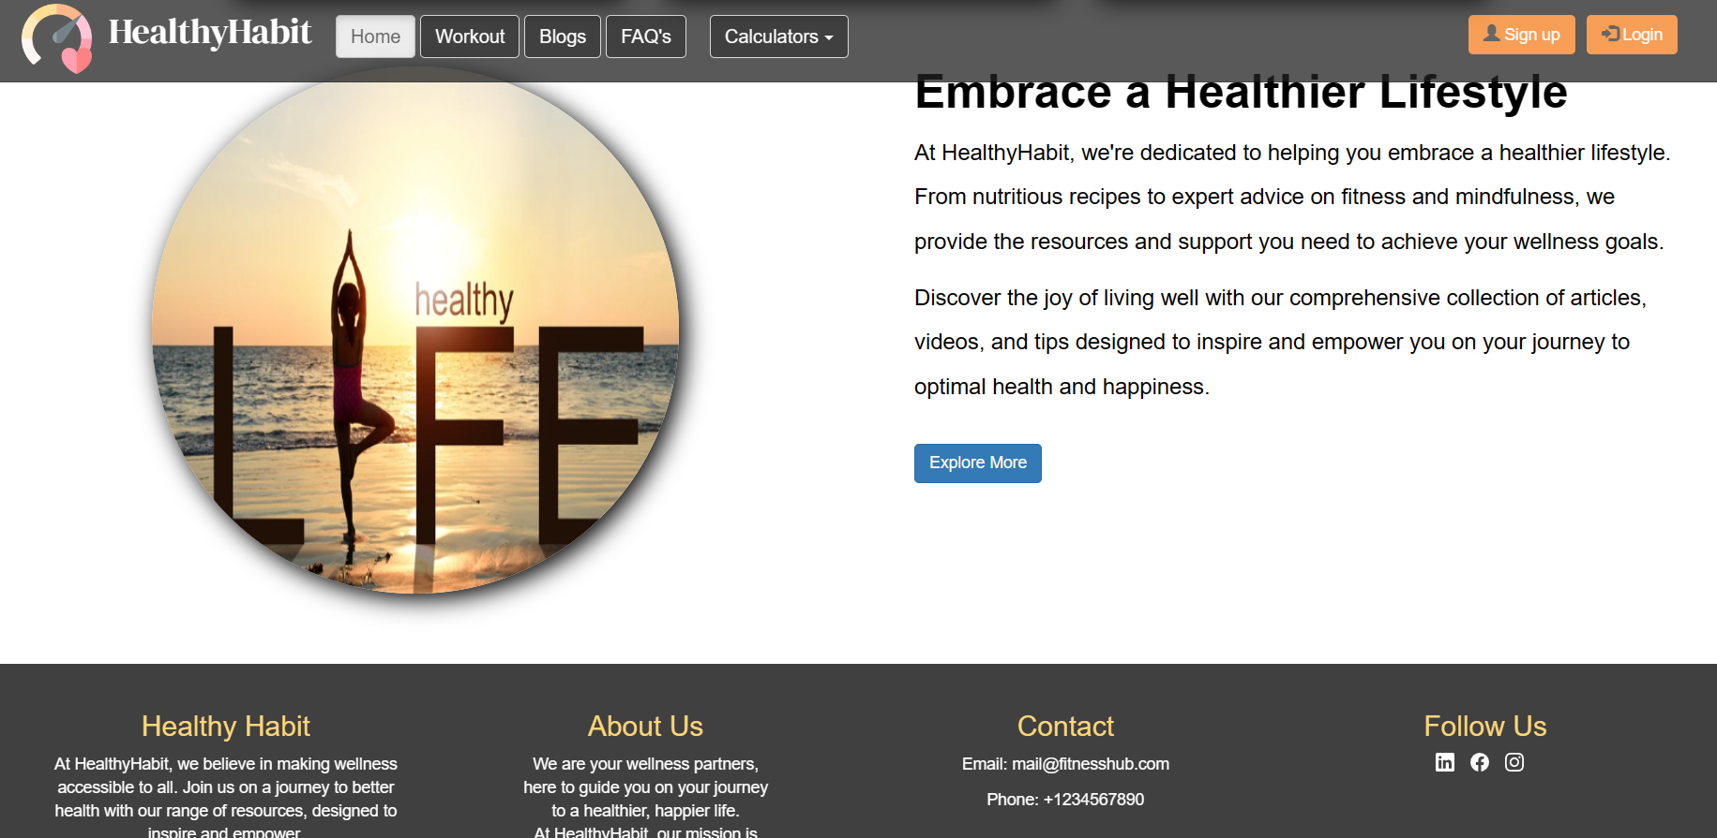

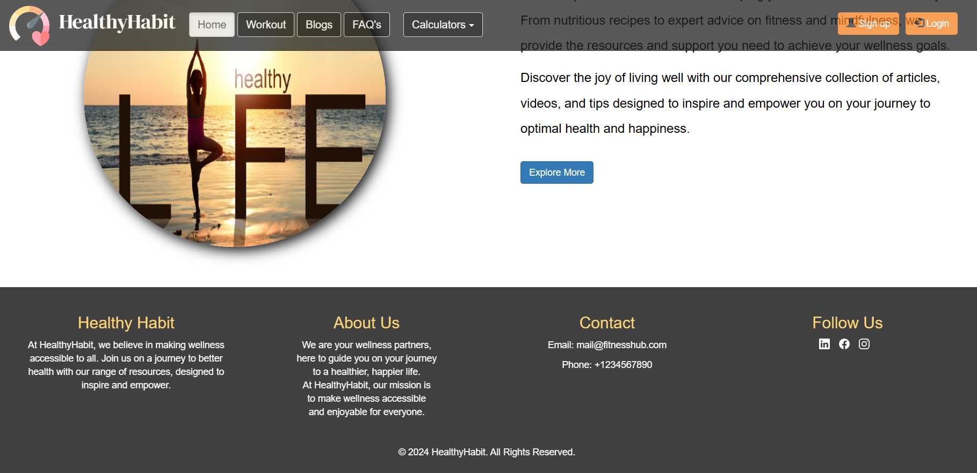

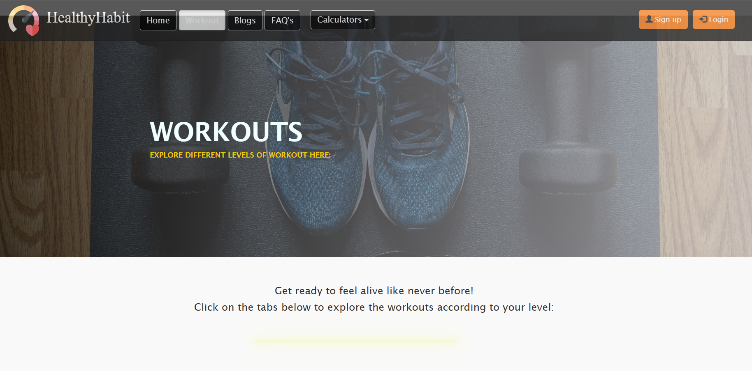

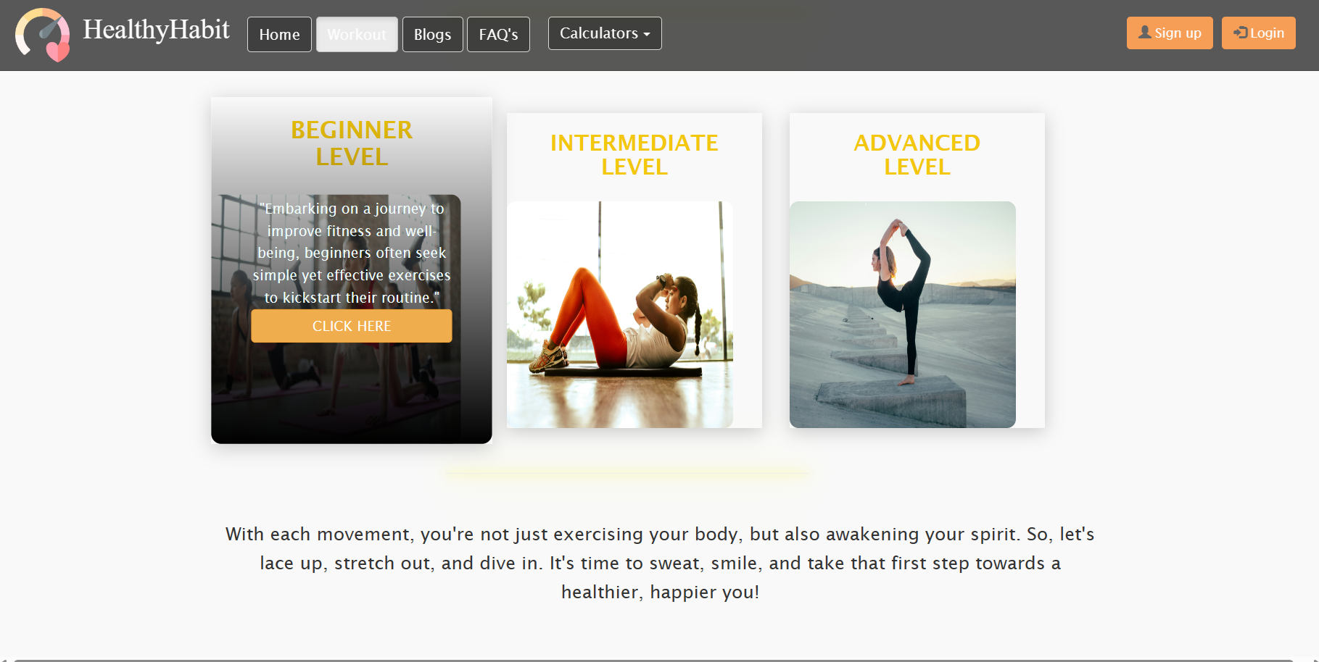

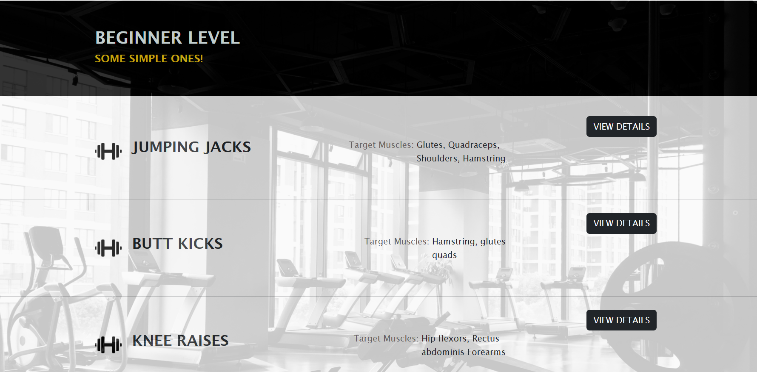

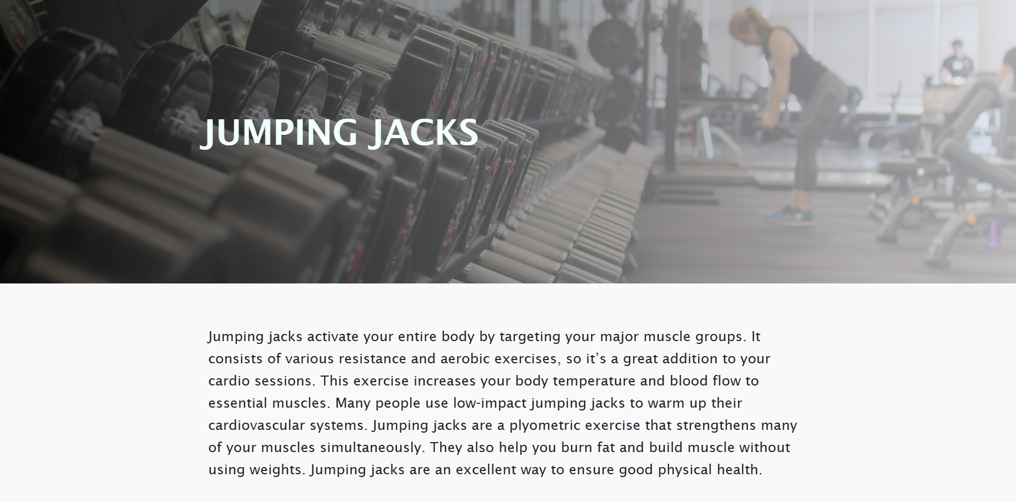

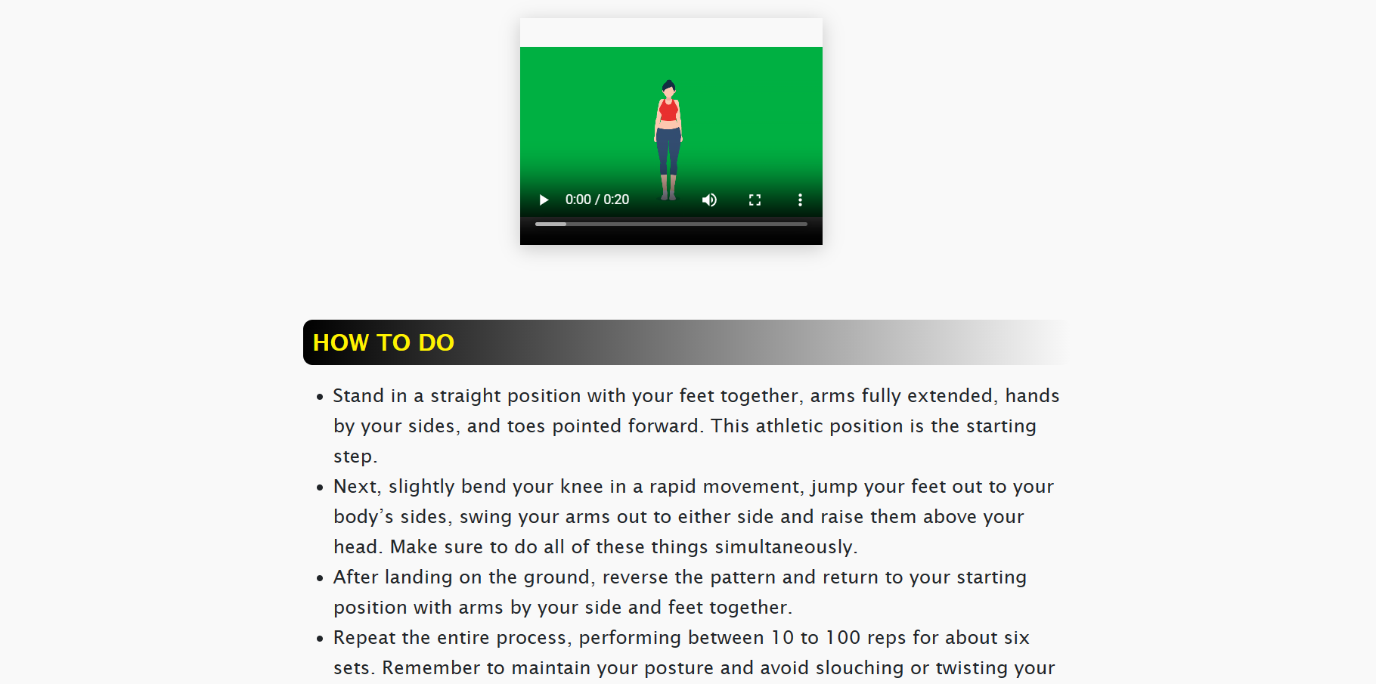

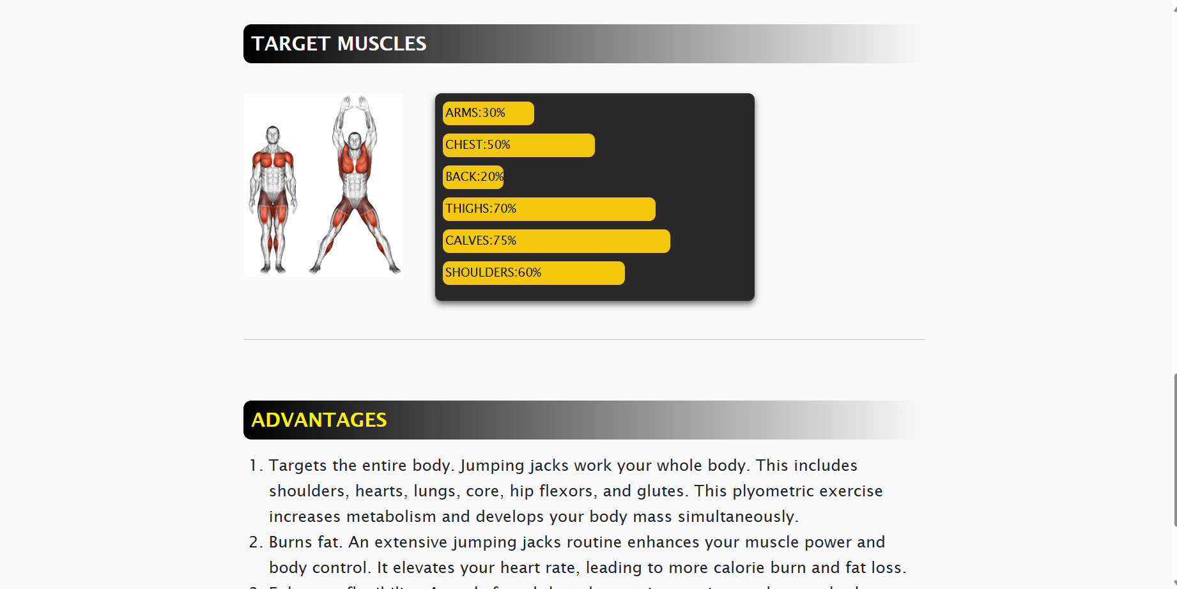

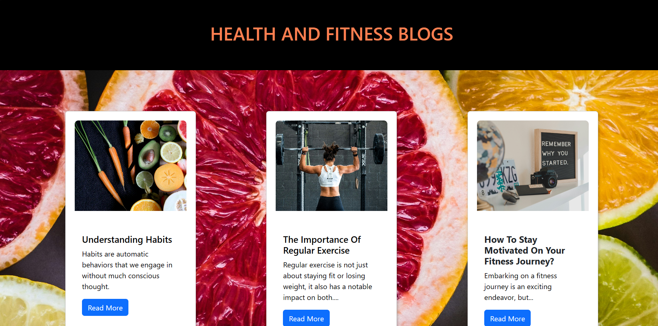

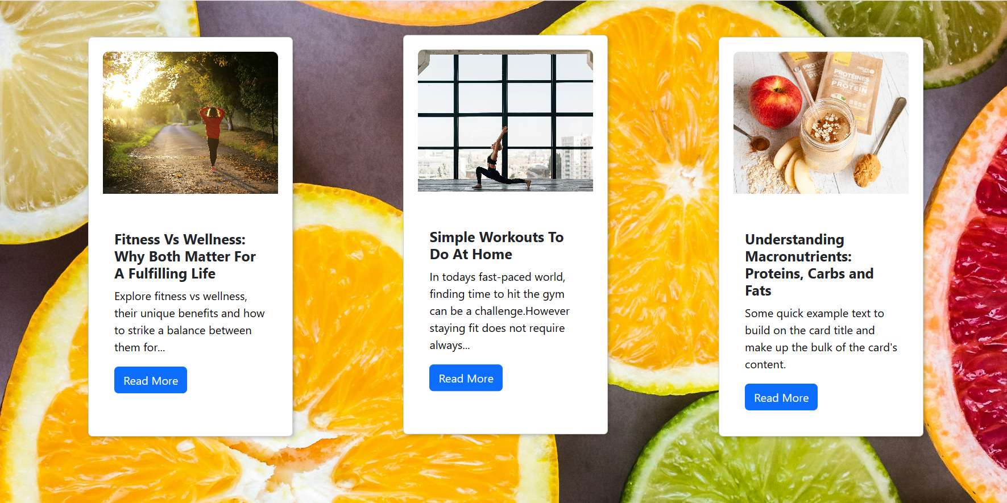

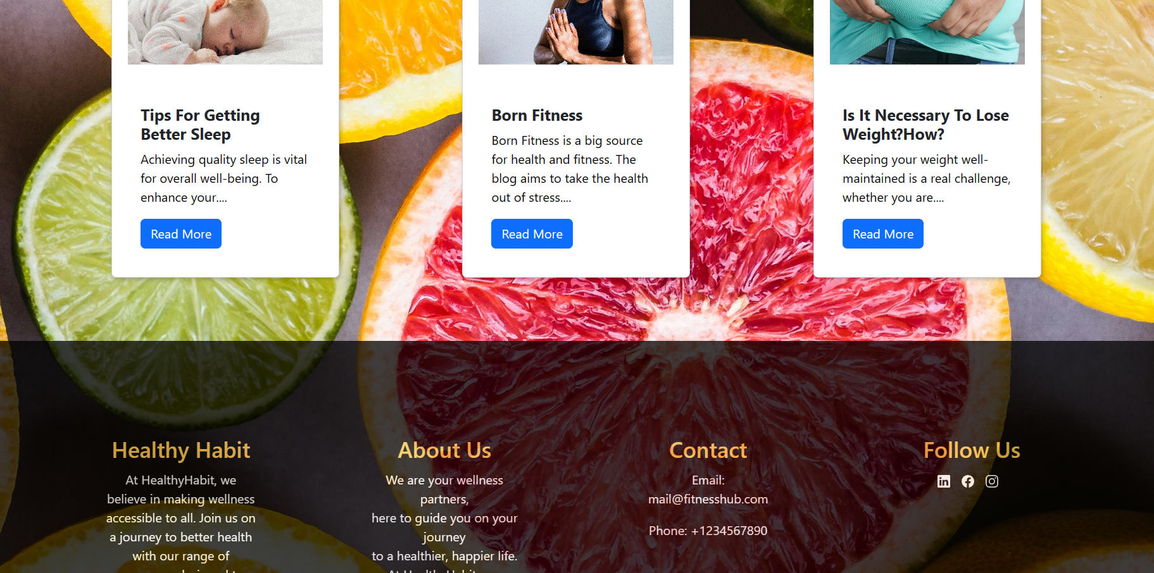

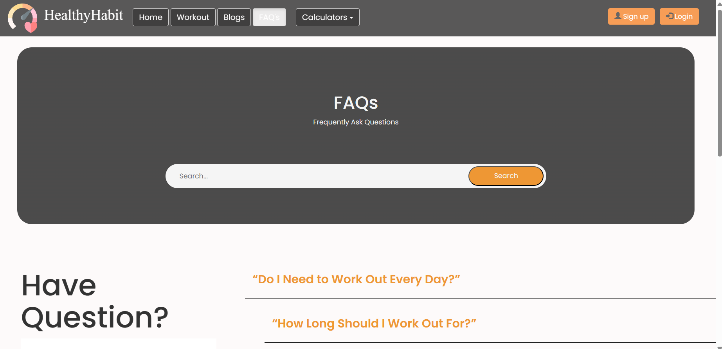

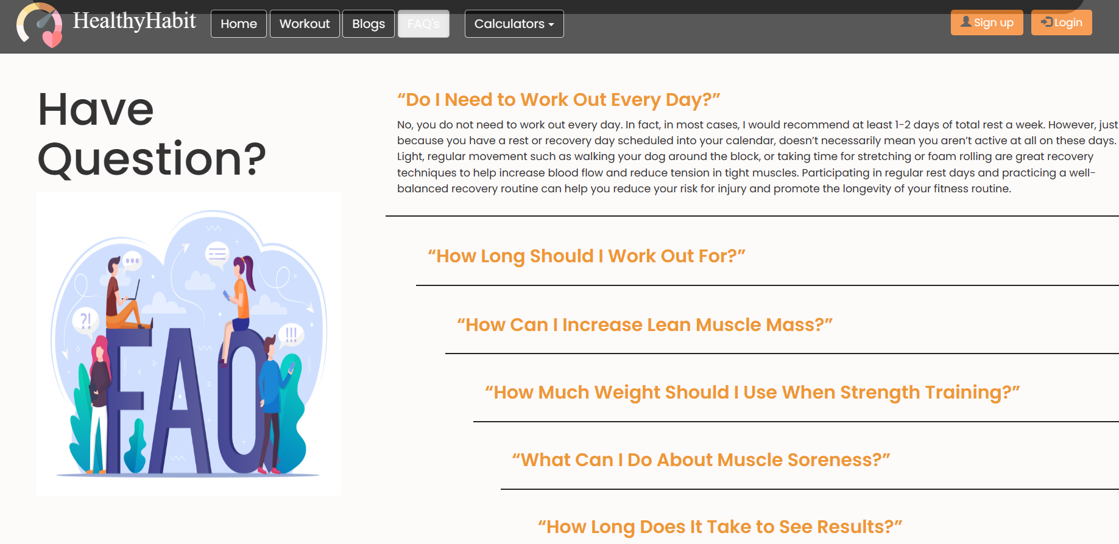

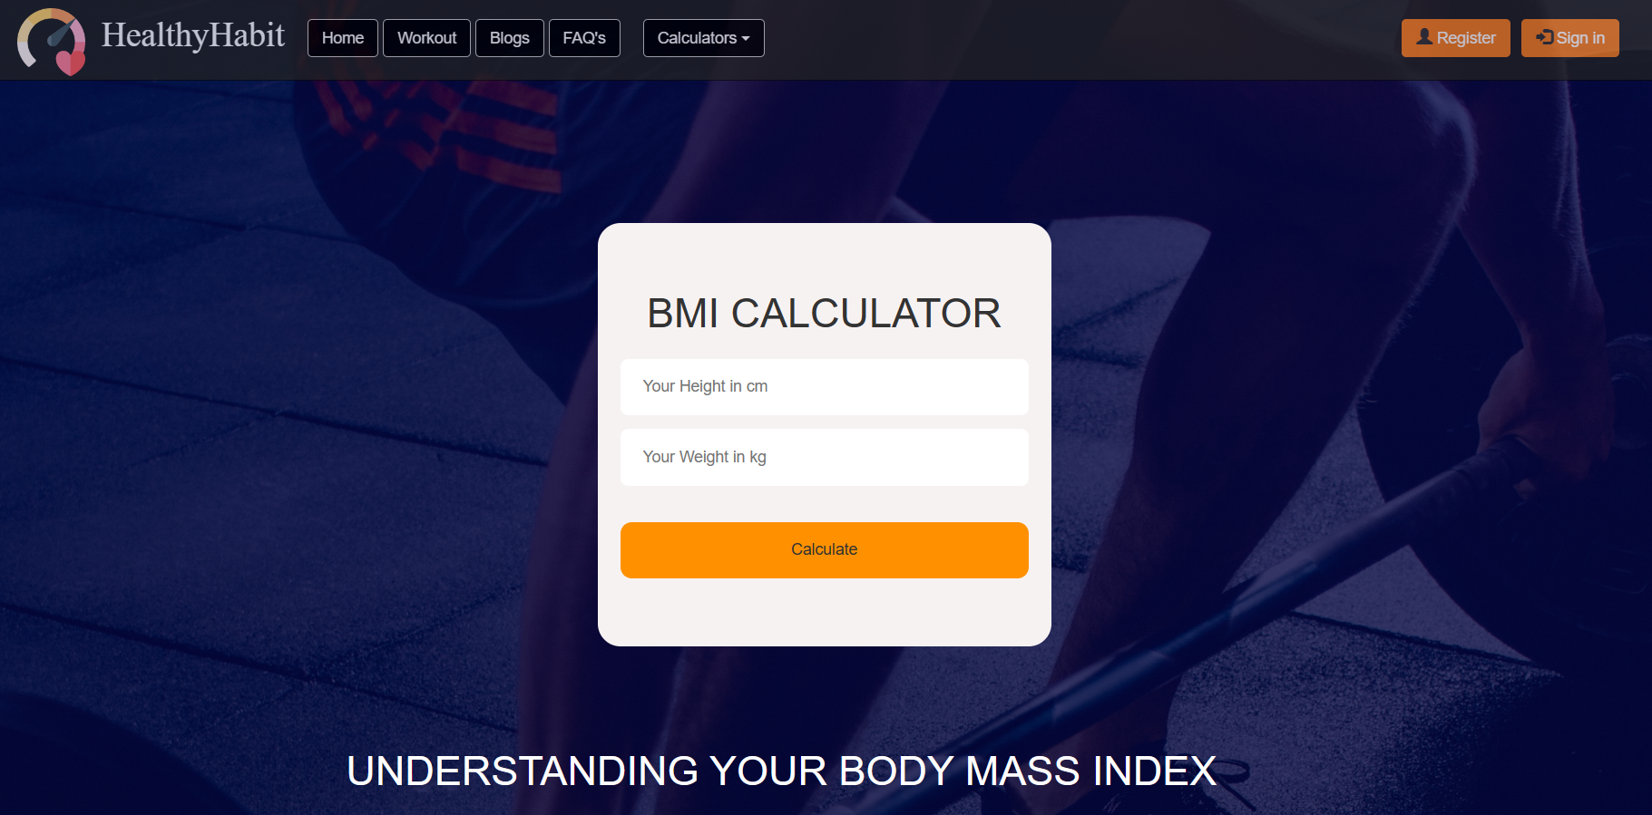

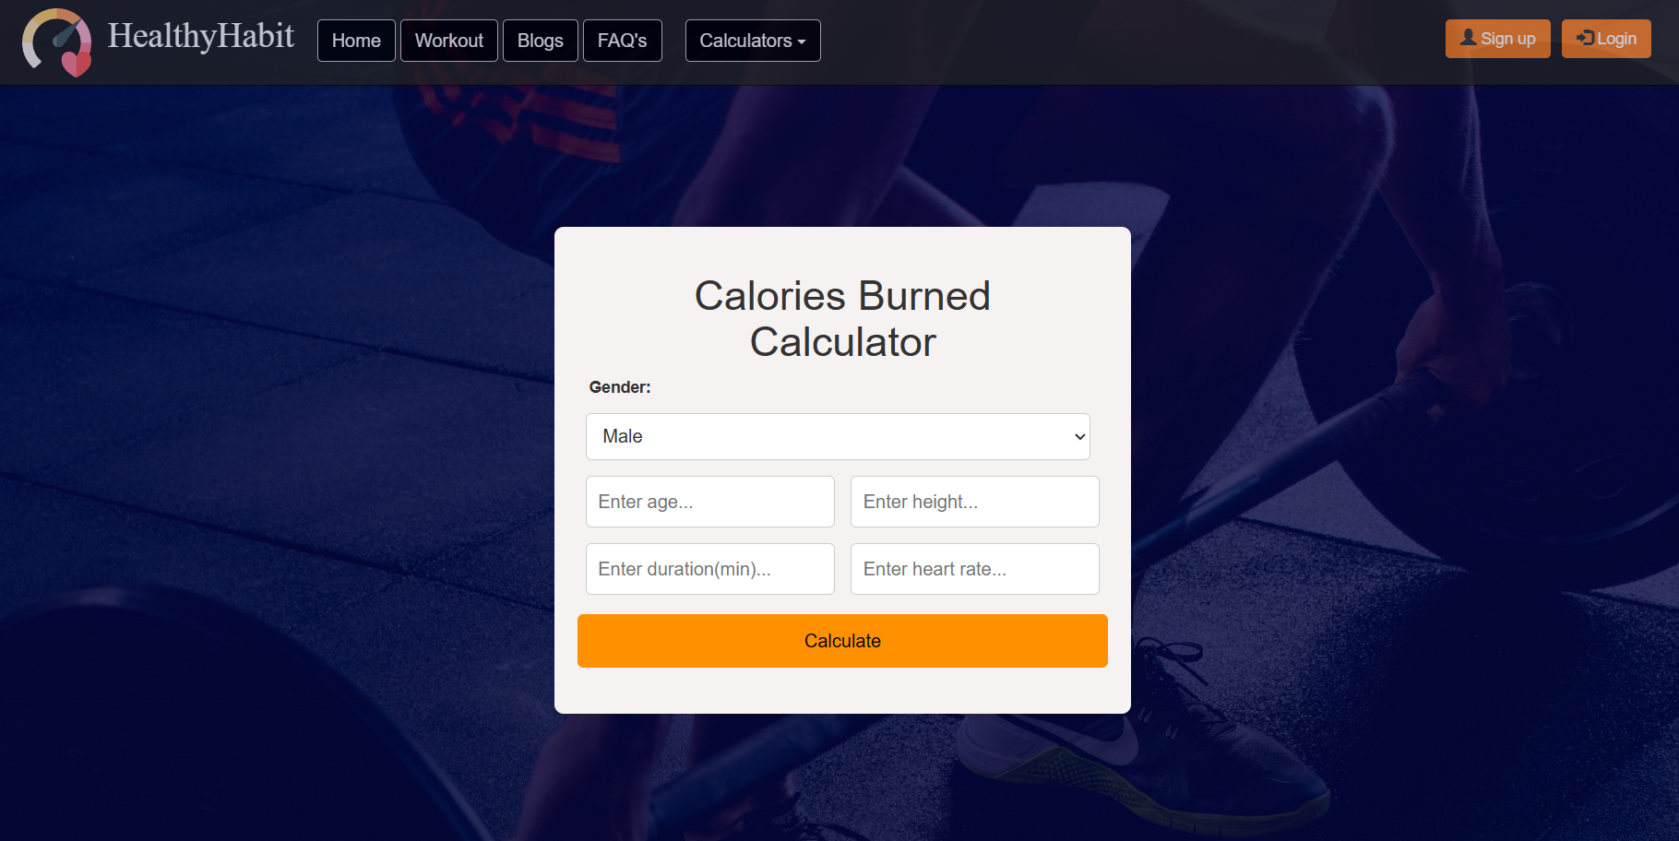

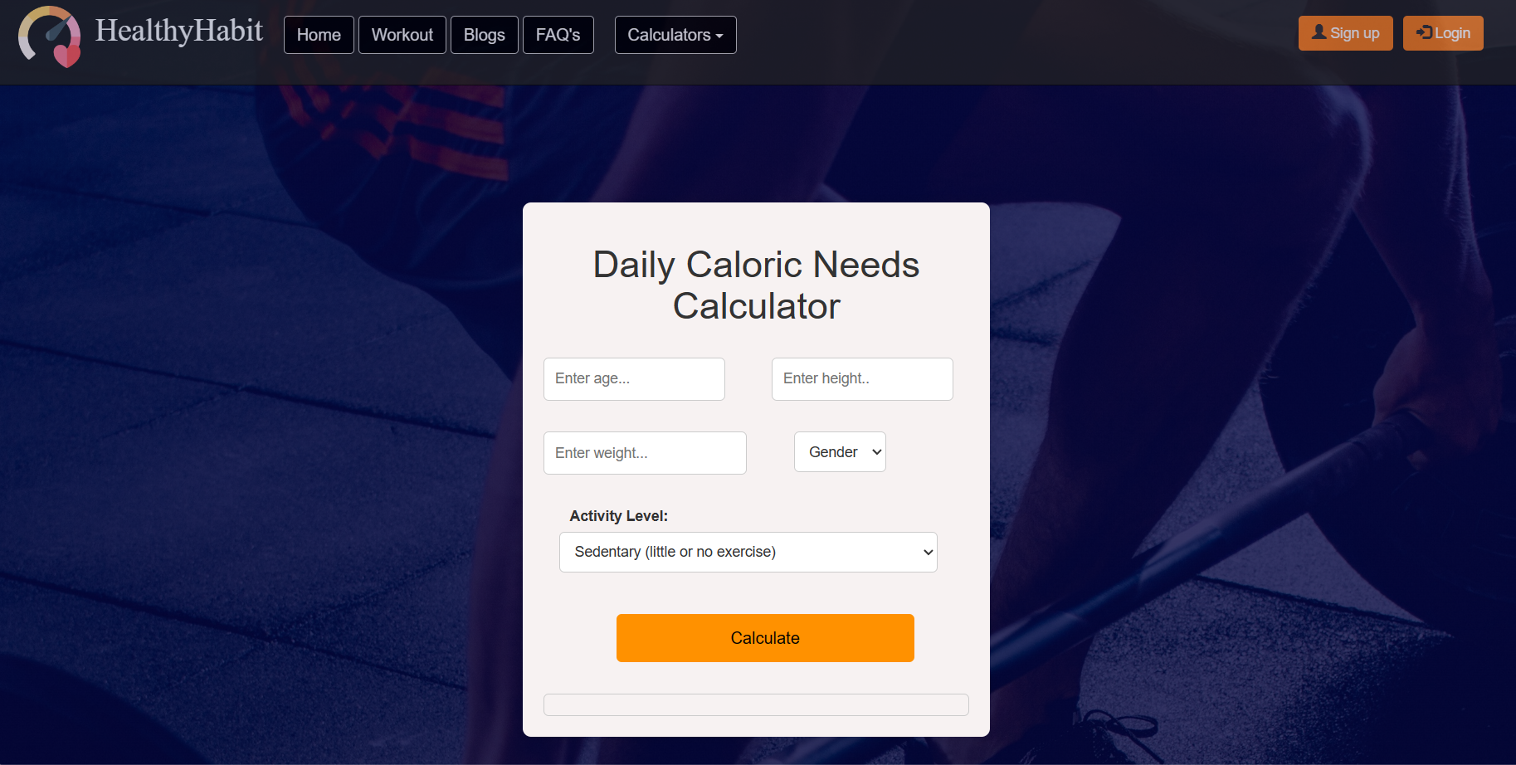

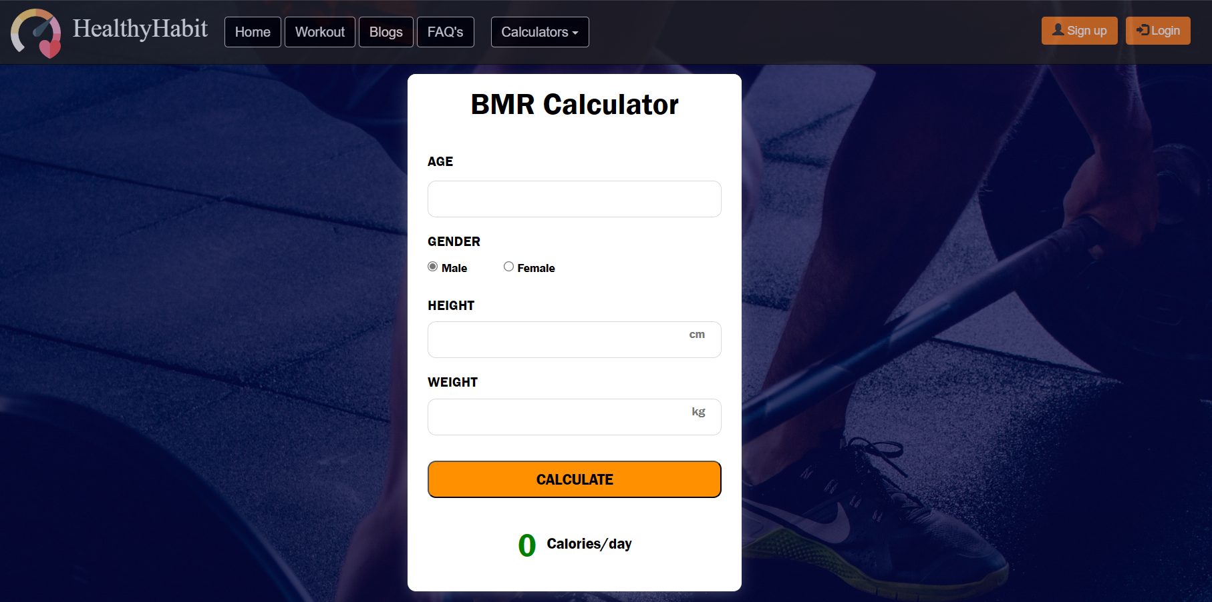

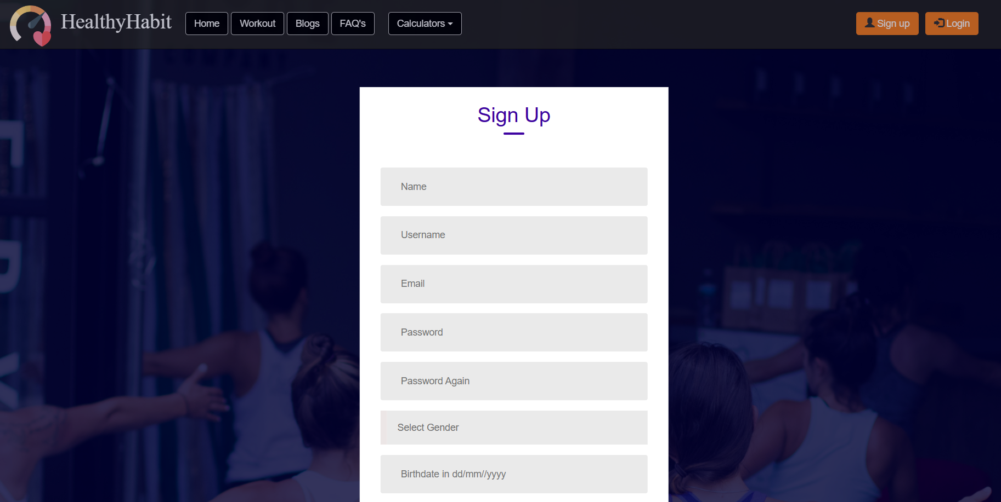

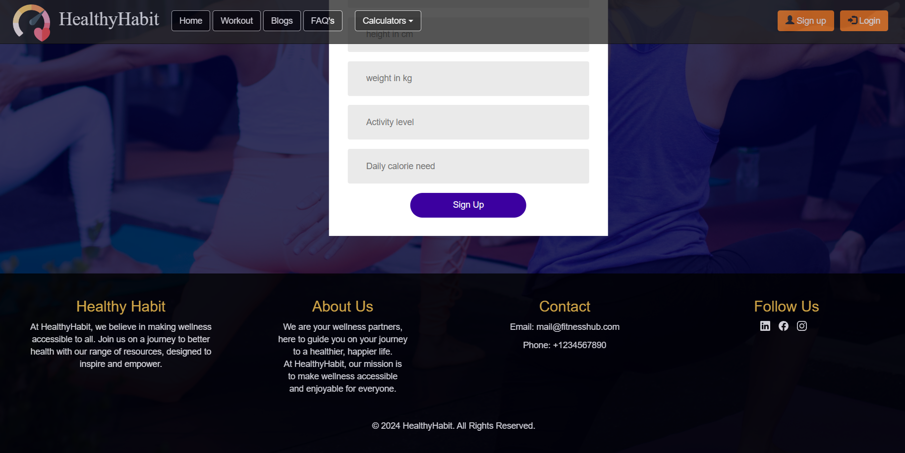

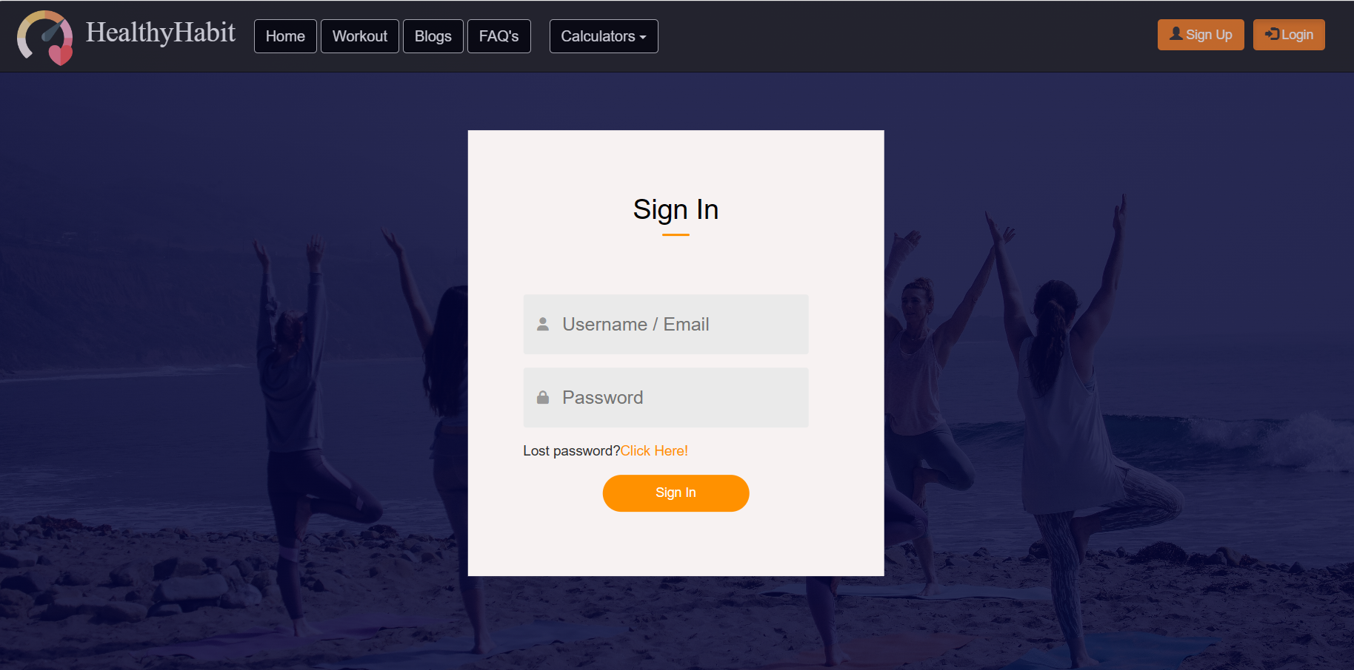

**Website link:**

[**https://healthnfitness-web.github.io/**](https://healthnfitness-web.github.io/)

**Conclusion:**

Our health and fitness blog website provides valuable insights and practical tips on exercise, nutrition, motivation, and overall wellness. With engaging content and easy navigation, we aim to inspire and empower readers to prioritize their health and embark on a path to lifelong well-being.